PIZZA SALES SQL QUERIES

**Total Revenue:**

SELECT SUM(total_price) AS Total_Revenue FROM pizza_sales;

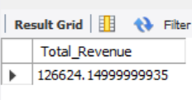

**Average Order Value:**

SELECT SUM(total_price) / COUNT(DISTINCT order_id) AS Average_Order_Value FROM pizza_sales;

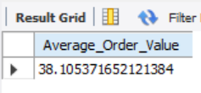

**Total Pizza’s Sold:**

SELECT COUNT(quantity) AS Total_pizza_sold FROM pizza_sales;

**Total Orders:**

SELECT COUNT(DISTINCT order_id) AS Total_orders FROM pizza_sales;

**Average Pizza’s per order:**

SELECT SUM(quantity) /COUNT(DISTINCT order_id) AS Average_pizza_per_order FROM pizza_sales;

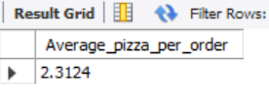

**Daily Trend for total Orders:**

SELECT DAYNAME(order_date) AS order_day, COUNT(DISTINCT order_id) AS total_orders FROM pizza_sales GROUP BY order_day;

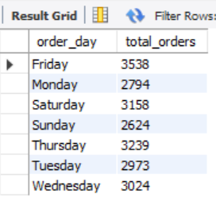

**Monthly trend for Total Orders:**

SELECT MONTHNAME(order_date) AS Month, COUNT(DISTINCT order_id) AS Total_orders FROM pizza_sales GROUP BY Month;

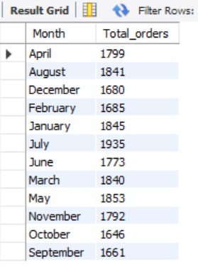

**Percentage of Sales by Pizza Category:**

SELECT pizza_category, SUM(total_price)*100 / (SELECT SUM(total_price) FROM pizza_sales) AS Total_Sales FROM pizza_sales GROUP BY pizza_category;

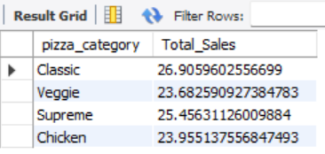

**Percentage of Sales by Pizza Size:**

SELECT pizza_size, SUM(total_price)*100 / (SELECT SUM(total_price) FROM pizza_sales) AS Total_Sales FROM pizza_sales GROUP BY pizza_size;

**Top 5 best sellers by Revenue, Total Quantity and Total Orders:**

Revenue:

SELECT pizza_name , CAST(SUM(total_price) AS DECIMAL(10,2)) AS Total_revenue FROM pizza_sales GROUP BY pizza_name ORDER BY Total_revenue DESC LIMIT 5;

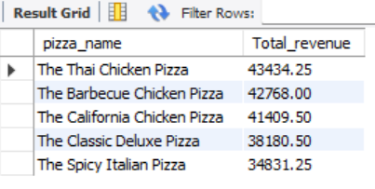

Total Quantity:

SELECT pizza_name , SUM(quantity) AS Total_quantity FROM pizza_sales GROUP BY pizza_name ORDER BY Total_quantity DESC LIMIT 5;

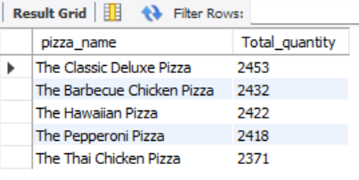

Total Orders:

SELECT pizza_name , COUNT(DISTINCT order_id) AS Total_orders FROM pizza_sales GROUP BY pizza_name ORDER BY Total_orders DESC LIMIT 5;

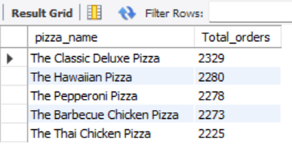

**Bottom 5 sellers by Revenue, Total Quantity and Total Orders:**

Revenue:

SELECT pizza_name , CAST(SUM(total_price) AS DECIMAL(10,2)) AS Total_revenue FROM pizza_sales GROUP BY pizza_name ORDER BY Total_revenue LIMIT 5;

Total Quantity:

SELECT pizza_name , SUM(quantity) AS Total_quantity FROM pizza_sales GROUP BY pizza_name ORDER BY Total_quantity LIMIT 5;

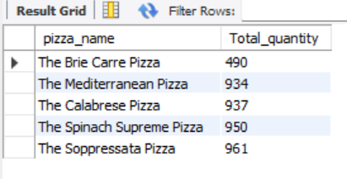

Total Orders:

SELECT pizza_name , COUNT(DISTINCT order_id) AS Total_orders FROM pizza_sales GROUP BY pizza_name ORDER BY Total_orders LIMIT 5;

